Open a command prompt and type the below command

ssh-keygen -t ed25519

I recommend leaving the passphrase empty

Once this is complete browse to the location that you created the key pair and copy the ssh key

Then go to github and go to your settings

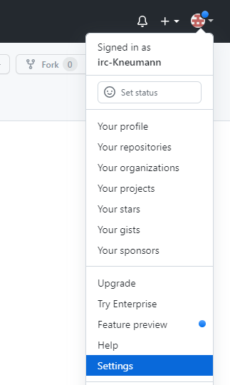

Go to SSH and GPG keys and paste the key in below. I put my title as work laptop.

Now when you pull from a repo you can select the SSH option

